Getting into hwb and google classroom

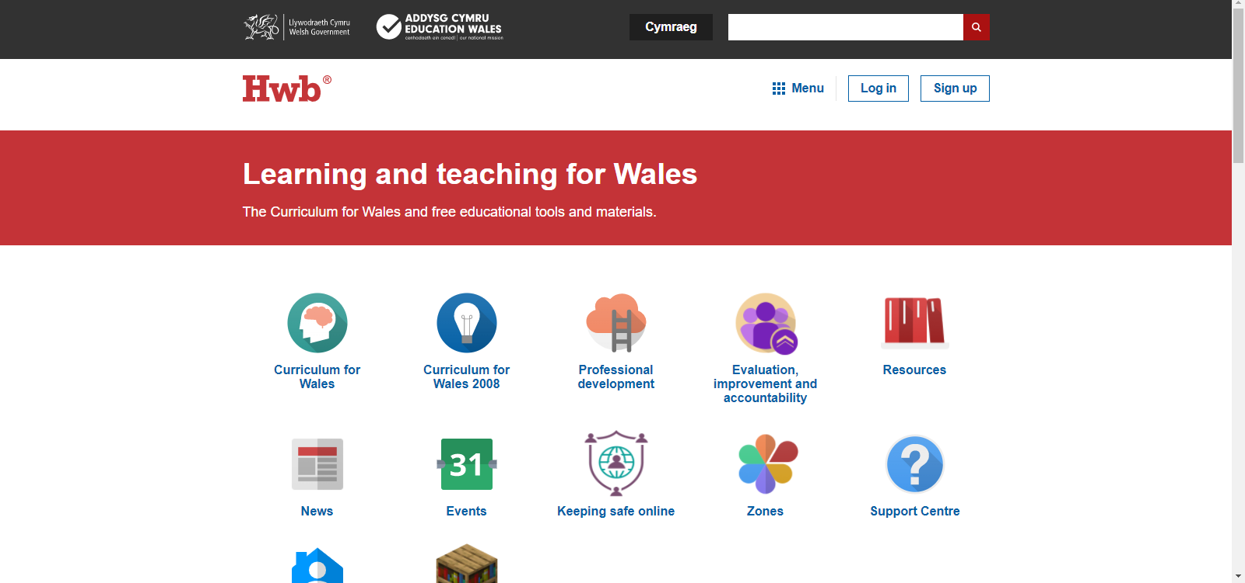 | Copy and paste the following address into the address bar, alternatively you can just click the link ​ https://hwb.gov.wales
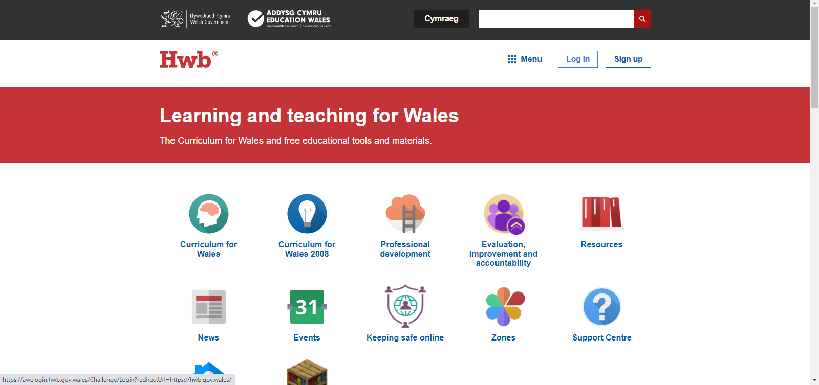 | Click on the log in tab near the top right of the screen.
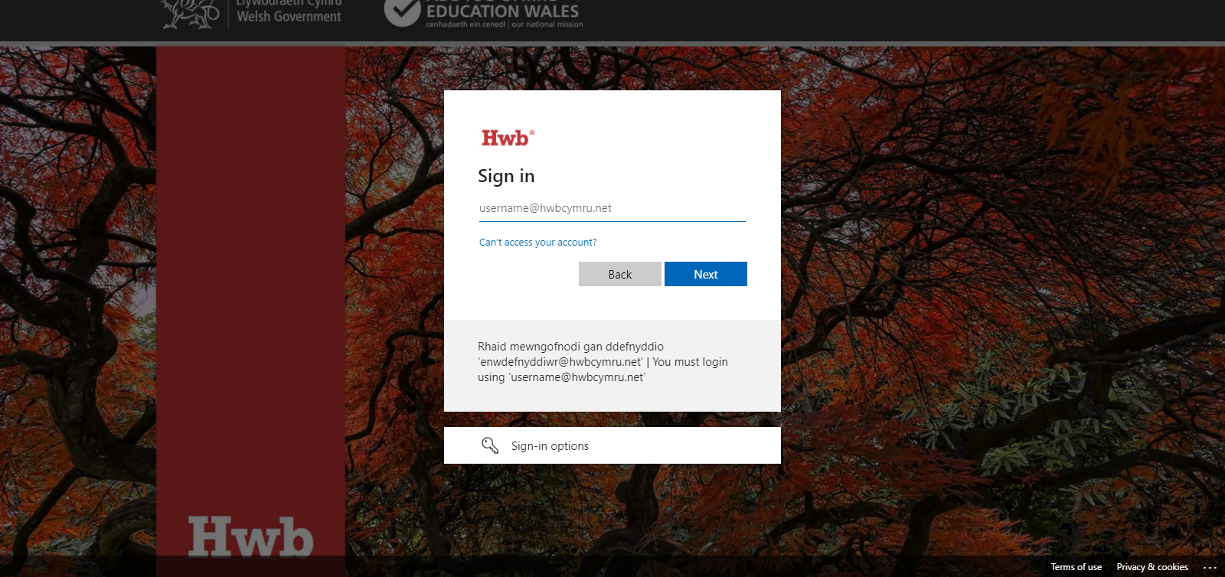 | Sign in using the email address …. …...@hwbcymru.net  Click next.  You will then get a screen to add the password – (this is case sensitive)
 | Up in the top right you should now see that you are logged in as you. If there is more than one person using the device, make sure they log off/sign out here at the end of their session or it automatically remembers the last person and you will struggle to get onto your own settings.
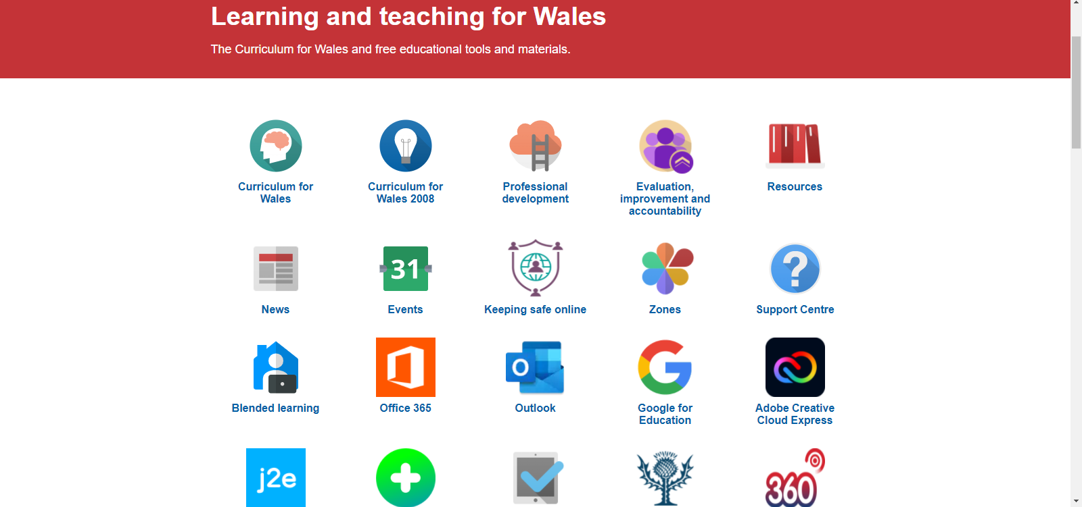 | Now to get into the google classroom.  Click on ‘Google for Education’.
This is where it could all go wrong!
You need to access the google classroom through the hwb email.
If you see a screen like this, that’s great, add another user by typing in the hwb email address, for the first log in it will ask if you give permission etc and if you are a student.
If you do not see this screen from what I can gather it has automatically picked up a previous google account on the device. What I suggest is that up in the right-hand corner somewhere there will be a cog or something for settings, click on this and a drop down will come up – you need to sign out of the previous email account. I can’t show you a screen shot of this really as don’t have one sorry but that is what you need to do.
Then try going in again.
Hopefully you have been able to add your hwb into the email box and click next.
To access our classroom, we only allow our pupils in, so using a private account will not allow you to see what is there.
The initial on the far right top corner shows it is you. This is where you click to log out at the end.
If you see this screen, you just need to click ‘join’ and you will be in.

If you don’t see this screen you can join our classroom by clicking on the + sign up near the top right and then adding the class code.

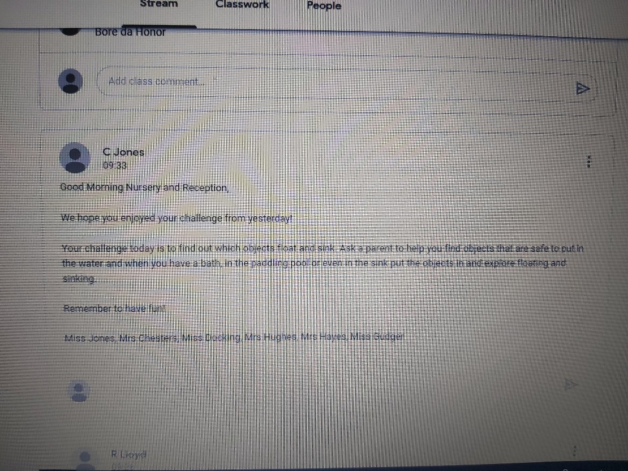 | You can scroll back through the stream to see previous messages.
 | When you have finished it is really important you sign out of google, to do this, click on your initial icon in the top right, the drop-down menu will appear and you can sign out.
I really hope this helps the remaining children who have struggled to access the classroom.

Any problems, please do email me.

