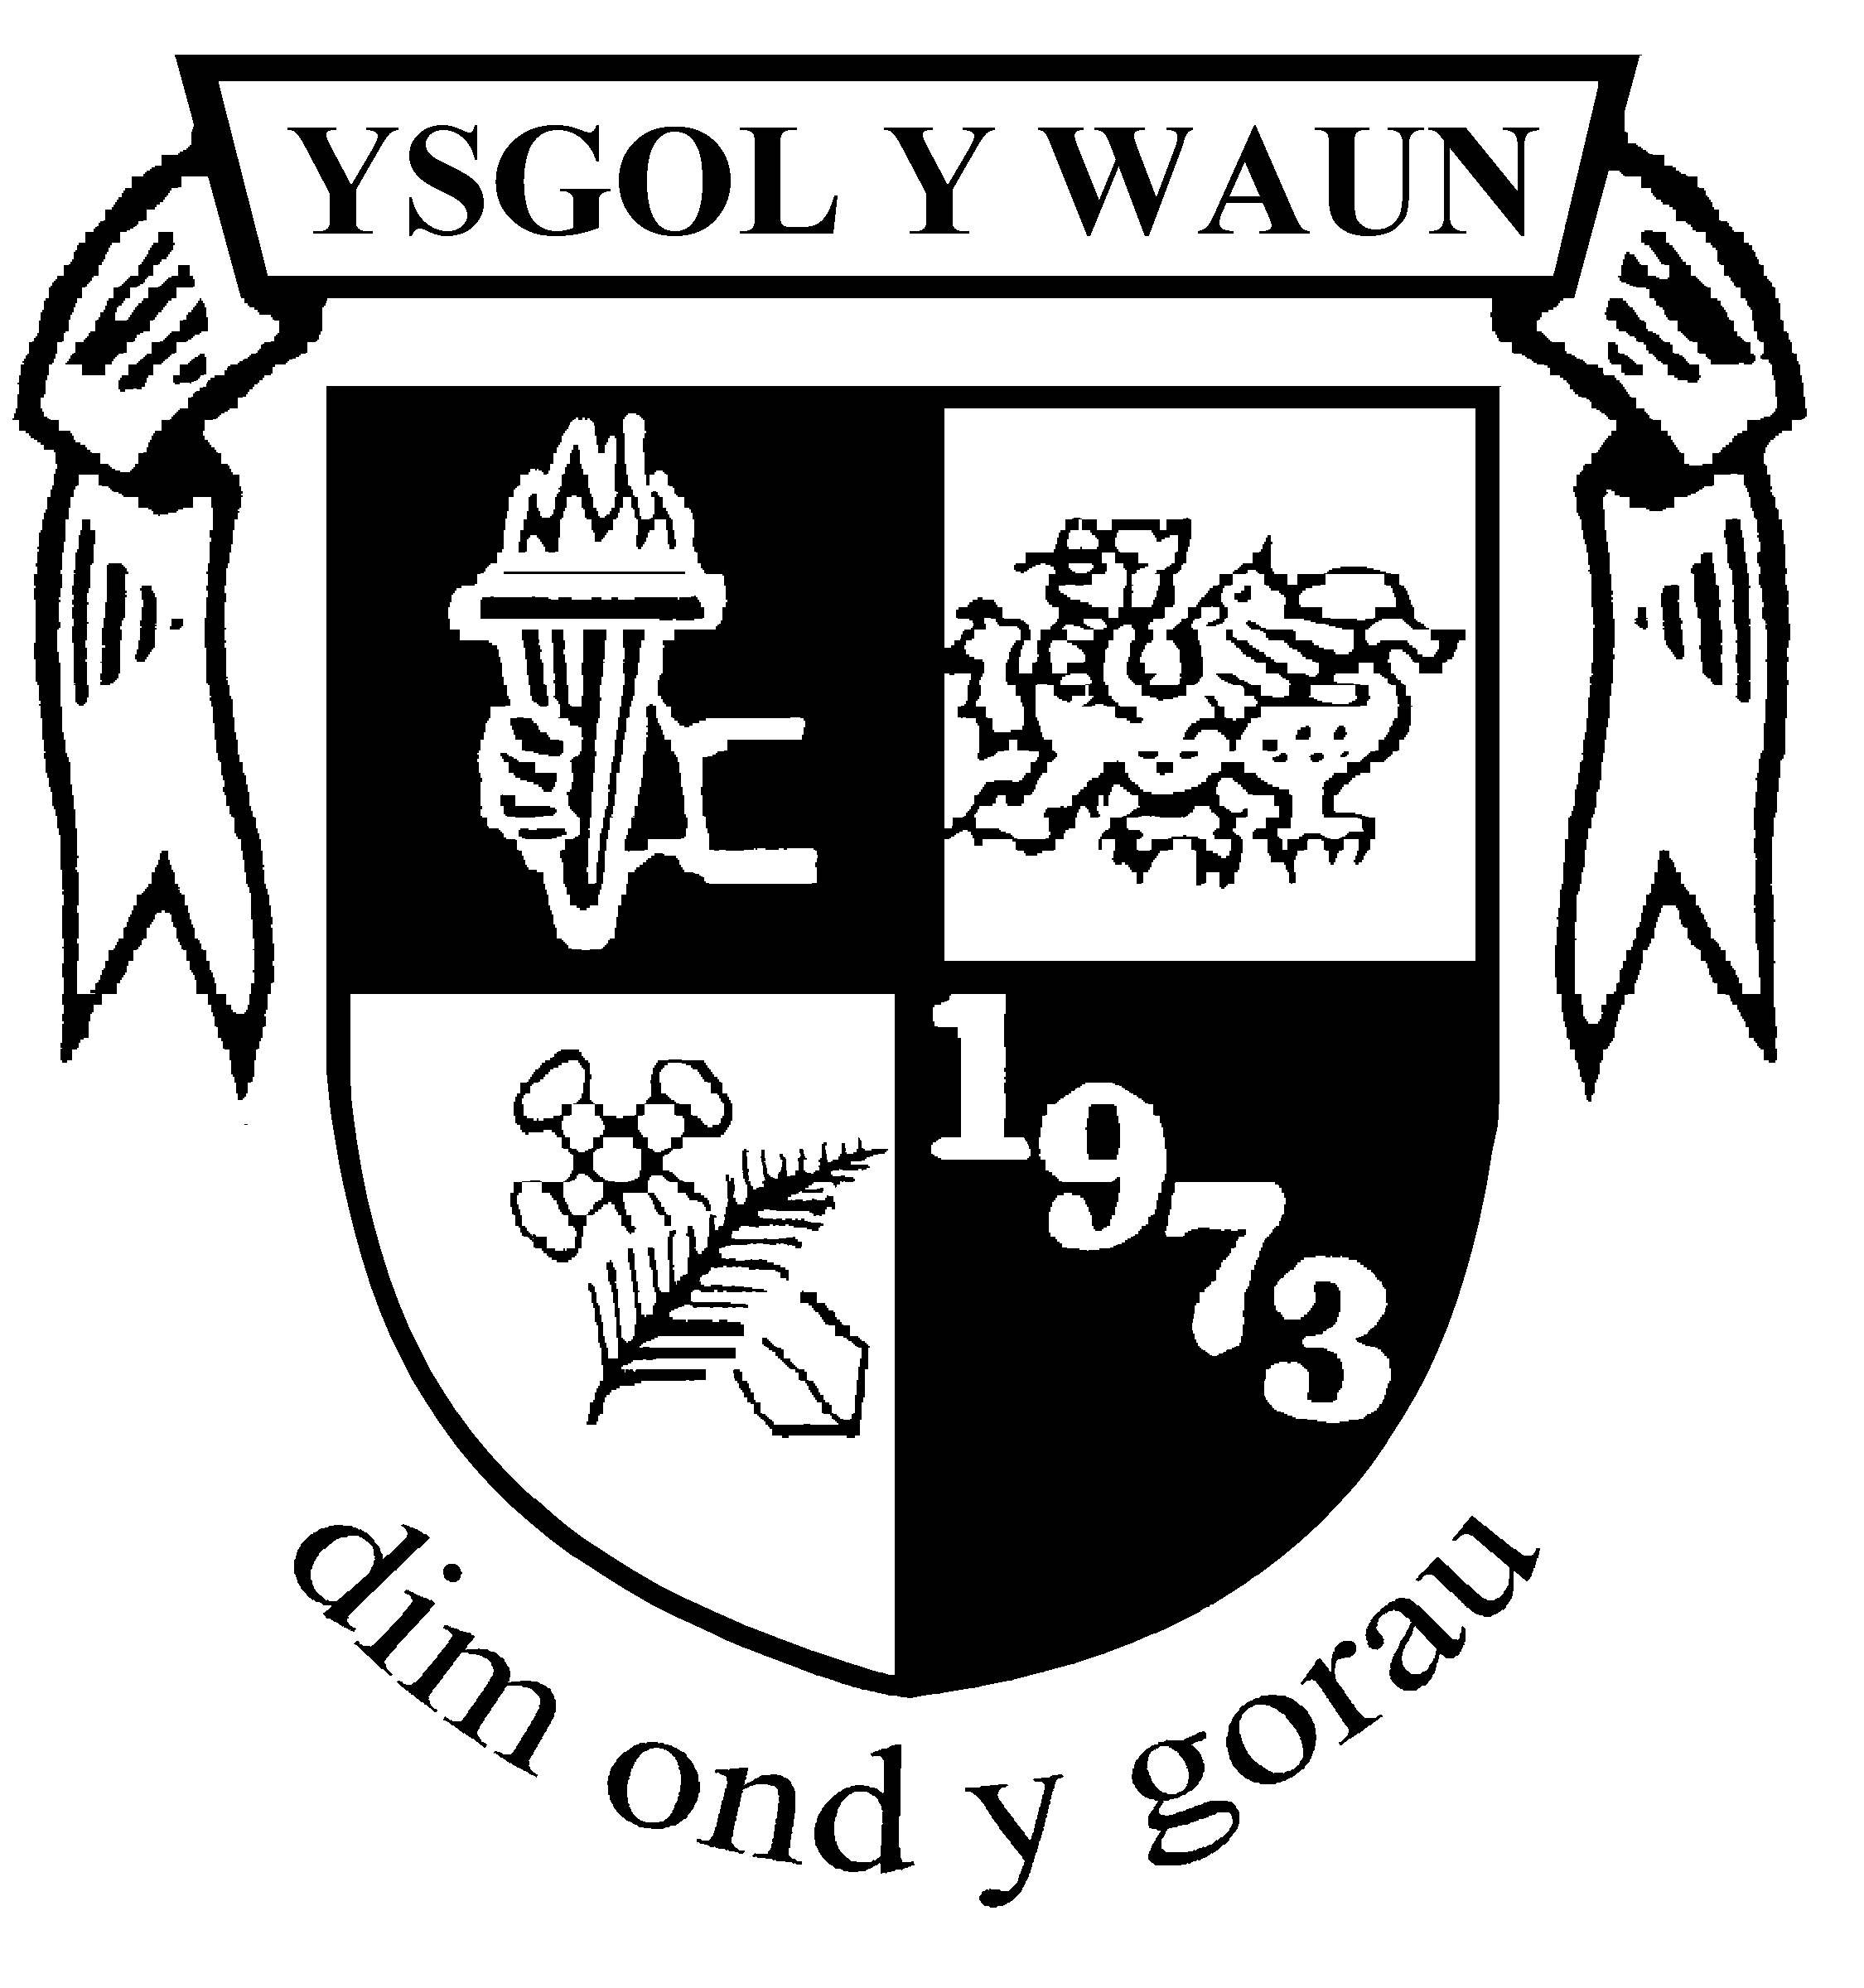  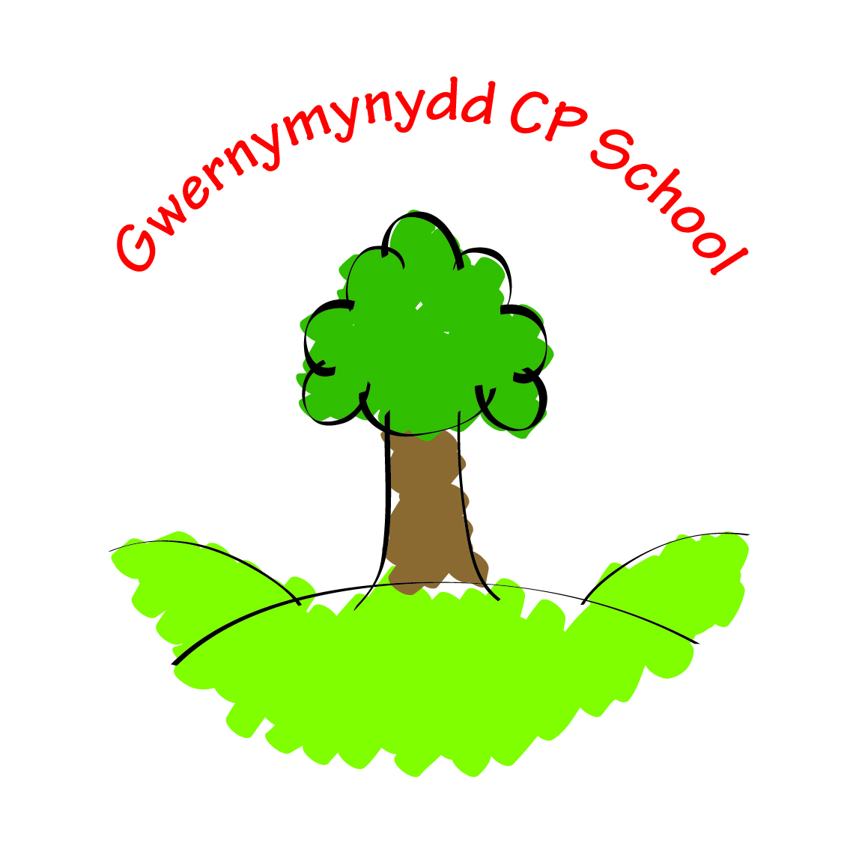 | HAFOD FEDERATION OF SCHOOLS  GWERNYMYNYDD CP AND YSGOL Y WAUN

GOVERNING BODY ANNUAL REPORT TO PARENTS

2022-23

Our Vision:

An inclusive learning environment enabling all to succeed.

Our Mission:

Nurturing all to flourish, broadening knowledge, skills, and experiences

Our Values:

Creativity – helping our children develop as enterprising, creative contributors​.

Courage – encouraging our children to become ambitious and capable learners​.

Respect – nurturing our children to become ethical informed citizens​.

Resilience – supporting our children to become healthy confident individuals.

PREFACE

During 2023 – 2024 we celebrate two major landmarks in the history of our schools. These are our five years as a Federation of schools and fifty years since both new schools opened in 1973. In both villages you can still see the former stone-built schools which pupils attended before then. Happily, both buildings remain in use as within the villages.

We aim to celebrate those fifty years in two main ways. Firstly, the pupils will be doing some studies of the local area and creating a time capsule in memory of all that has happened in that time but also as an opportunity to look to the future.

We also intend this anniversary to be the theme of the summer fayres. We hope as many of you as possible can attend the fayres and extend an open invitation to all past pupils, staff, and parents to attend our celebrations.

Federating the two schools has been a great success. Staff from both schools work closely together in a number of ways, including designing the curriculum and having joint visits and trips. There is a regular interchange of staff between the schools which allows us to maximise the opportunities available to us in terms of staff expertise and experience. The children too often work together and join each other in number of activities. We are stronger together as the saying goes. We also save money by paying jointly for some services, rather than separately.

The school year 2022-2023 saw us recover ground lost during the difficult Covid days. We judge that pupils have now made up any ground lost during that time and are able to look to the future with optimism. We thank staff, pupils, and parents for all their efforts both during and after the crisis.

The Federation continues to deliver the creative schools’ initiative in the local area. In Lead Creative Schools, pupils, teachers, and creative professionals work together to implement creative projects. Our teachers experience the benefit of collaborating with creative professionals to explore creative approaches to teaching and learning. We are very pleased with progress so far.

We hope you find this report helpful and informative. If you want to know more, please contact the school office.

CONTENTS

 | Section
1 | The Governing Body
2 | Annual meeting with parents
3 | School comparative data
4 | Attendance information
5 | Targets for reducing the level of unauthorised absence
6 | Targets for improvement set by the governing body
7 | Financial statement for the school set by the governing body
8 | Professional development of staff
9 | Reviews of policies or strategies set by the governing body
10 | The school curriculum
11 | The language category of the school
12 | Pupils’ use of the Welsh language in school
13 | Community involvement
14 | Arrangements for pupils with additional educational needs
15 | Arrangements for participation in sport
16 | Extra curricula activities
17 | School visits
18 | Provision of toilet facilities and keeping them clean
19 | Actions taken to promote healthy eating and drinking by pupils of the school
20 | Changes to the School prospectus
21 | Dates for the school year 2022-23
22 | The school Day
23 | Distribution

This report contains the information required by the Welsh government. Some other sections have been added for your information.

- The Governing Body
Members of the Current Governing Body for the Academic Year 22-23

Name | Role
Ms Kim Brookes | Community Governor and Chair
Mrs Louise Ankers | Headteacher
Mr Dafydd Johnson | Teacher Governor
Mrs Andrea Taylor | Teacher Governor
Mrs Sally Hughes | LA Governor
Mrs. Adele Davies-Cooke | LA Governor
Mr. Trevor Payne | LA Governor
Mr. Neil Dyment | LA Governor
Mrs. Hannah Whiteaker | Parent Governor
Mrs Corey Williams | Parent Governor
Mrs Katie Lynch | Parent Governor
Mrs Ailsa Snow | Parent Governor
Mr Steve Foley | Minor Authority Governor
Ms Lauren Roberts | C0-opted Governor
Mrs Sian Parry | Community Governor
Ms Katie Thomas | Community Governor (until October 2022)
Mrs Rachel Foley | Community Governor (from October 2022)
Mrs Sue Coles | Community Governor
Vacancy | Staff Governor
Vacancy | Staff Governor

Officers of the Governing Body (current)

- Headteacher, Mrs Louise Ankers
- Chair of governors: Miss Kim Brookes
- Vice Chair of governors: Mrs Katie Lynch
- Clerk to the Governors: currently vacant

These officers can all be contacted at:

- Letter: Gwernymynydd CP School Godre’r Coed Gwernymynydd Flintshire CH7 4DT
- Email: gmmail@hwbcymru.net
- Phone: 01352 756756
- Letter: Ysgol y Waun, Y Waen, Gwernaffield, Flintshire CH7 5DP
- Email: ywmail@hwbcymru.net
- Phone on 01352 740362

Summary of Governing Body Meetings

The governing body has met at least twice each term. Following the virtual meetings held during the pandemic, we are again meeting in person. Meetings alternate between Ysgol Gwernymynydd and Ysgol y Waun.

Committees are intended to share the workload fairly amongst governors, by covering some of the detailed work involved outside of the main meetings. Each committee has its own terms of reference. These are updated at the start of each academic year. Each committee elects its own chair. Its key decisions and recommendations are recorded and reported back to the next full governors’ meeting, for their consideration.

The Federation’s Committees

Name | It meets | What it does
Standards, performance, and curriculum | Once a term | Data, targets, curriculum for Wales, Annual report to parents, autumn, and spring term progress
Wellbeing | Once a term | Wellbeing of staff and pupils, Safeguarding, Behaviour and challenging bullying, attendance and homework, community, and healthy eating
Staffing and Personnel | Once a term | Staffing structure, staff progress on performance review
Finance | Once a term | Half year budget review, yearend budget check, set draft budget for full governors
Pay review | Once a term | Combines with the finance committee
Premises, health, and safety | Twice a term | Annual audit of premises, risk assessment update, outdoor safety, health issues
Policies | Once a term | Regular review policy timetable. Present draft policies to full governors
Pupil discipline and exclusion | As required
Staff disciplinary | As required
Complaints | As required
Pay Review appeals | As required
Grievance | As required | To hear staff grievances

After each meeting, the chair of the committee feeds back to the next full governors; meeting

All meetings are minuted. Once approved, the minutes can be found on our websites.

There is a statutory requirement for all new governors to attend an induction course. In addition, all governors must attend a course in order to improve their understanding of the data which is used to monitor the schools’ success in improving standards of learning.

The Governors enjoy good links with the schools and their activities. Following the pandemic, governors have now resumed their visits to school, to see classes in action. Governors report back to the Headteacher and full governing body on these visits.

2. Meetings with parents

Annual parents’ meeting

The School Governors’ Annual Reports (Wales) (Amendment) Regulations 2013, which came into force on 4 May 2013, made a number of changes to the Principal Regulations. Section 94 of the Act enables parents to request up to three meetings in a school year with their school governing body. This replaces the previous requirement for a governing body to hold an annual parents’ meeting.

The new arrangements mean that instead of a governing body having to hold an annual parents' meeting, parents have a right to request a meeting on issues which concern them. This parental right may be exercised up to three times a school year, provided that the purpose of the meeting is to discuss issues which relate to the school and not individual pupil progress and achievement or grievances against a member of staff or the governing body.
As the school year 2022-23, ended our year group numbers were:

Number on roll
 | Y Waun | Gwernymynydd
Early Entitlement | N/A | 3
Nursery | 9 | 9
Reception | 2 | 8
Year 1 | 9 | 7
Year 2 | 6 | 11
Year 3 | 17 | 7
Year 4 | 7 | 10
Year 5 | 5 | 9
Year 6 | 6 | 10

Assessment, attendance, and targets for improvement

Following consultation in May 2021, the Welsh Government stated that the ‘statutory duty for governing bodies to produce a report will remain, but it would be inappropriate for reports to include performance and attendance data for 2020/21, as it cannot be compared to previous years. The Welsh Government cancelled the collection of annualised attendance data and suspended the reporting of school performance measures, for this year, and made a commitment that schools will not be held to account based on their learner outcomes.’

Assessments are currently ongoing throughout the school year. Pupils are being monitored and tracked and are given the correct intervention to ensure progress. Targets are being set on a daily basis through teacher and pupil feedback.
Termly attendance has been monitored closely and shared with the Governing body.

7. Financial statement for the schools set by the governing body
Outturn for the last Financial Year, 2022-23

Employees: All staffing costs, teaching, support, cleaning, caretaking, admin including supply cover, insurance schemes etc.

Premises: Repairs, maintenance, legal checks (water, gas, electric etc), grounds maintenance, heating, electricity, water, rates, cleaning materials.
Transport: Any staff travel expenses. Never claimed.
Supplies: Resources, books, paints, equipment, IT, postage, telephone, alarms, subscriptions to online schemes.
Pupil/Adult Meals: Are paid for and show in the income element, courses are training.
SLA: What we pay to FCC for their service e.g.: school finance, HR, health & safety, property maintenance, additional learning needs, staff sickness insurance, maternity insurance, IT support.
Income: Money comes into school from WG grants, meals, pay awards, breakfast club, small school grants etc
See next page for details.

Ysgol Gwernymynydd

Heading | Formula Budgeted Allocation | Planned Spending | Actual Spending
Balance b/fwd from  2020/21 | 33398
Employees | 277183 | 374130 | 372974
Premises | 33376 | 20818 | -3655
Transport | 0 | 0 | 0
Supplies | 17420 | 7110 | 10115
Net Adult Meals/Courses | 0 | 7948 | 7916
Support Services | 18333 | 7948 | 18598
Income | 0 | 53415 | -83195
Total Costs | 379711 | 379711 | 379711
Move to Reserves | 0 | 4787 | 28831

Ysgol y Waun

Heading | Formula Budgeted Allocation | Planned Spending | Actual Spending
Balance b/fwd from  2020/21 | 69684
Employees | 352695 | 454916 | 457639
Premises | 48776 | 38719 | 38950
Transport | 0 | 0 | 0
Supplies | 21422 | 26239 | 19624
Net Adult Meals/Courses | 0 | 8942 | 8349
Support Services | 23987 | 23987 | 24600
Income | 0 | -69822 | -103611
Total Costs | 516564 | 516562 | 516564
Move to Reserves | 0 | 33582 | 71013

These figures have been supplied by Flintshire County Council, rounded to the nearest pound.

Grant funding

Schools receive various grants from the WG which are allocated using a formula based on school/community factors.
The Pupil Development Grant (PDG) allocations are based on pupils eligible for free school meals. The rate for PDG and EYPDG is £1,150 per eligible pupil. This funding is so valuable to schools and makes a significant difference to the provision of teaching and learning we offer our children. The objectives we identified for this grant are:
- Supporting eFSM learners using effective early identification and tracking systems
- Professional learning for staff to develop children’s speech, language, and communication skills
- Developing early literacy and numeracy approaches
- Supporting social and emotional learning
- Ensuring staff are highly trained
- Using effective diagnostic systems to tailor support.
The Education Improvement Grant (EIG) is allocated based on pupil numbers of Foundation Phase pupils alone and also whole school numbers. There are a range of objectives for schools to work towards in terms of using this funding and we identified:
- working towards the FP staff ratios
- improving teaching and learning
- improving the provision for and engagement of learners
- improved outcomes in literacy and numeracy
- development of excellent professional workforce
- leaders working together in a self-improving system.

Lastly, there is a Professional Learning Grant (PLG) which is based on staffing numbers. The main purpose of this funding is creating time in schools for all practitioners to make changes in practice and develop the skills they need to support delivery of the new curriculum for Wales and to enable schools to continue to adapt and access necessary support. The main expectation of the funding is to enable practitioners to develop their skills and practice to deliver high quality teaching and learning.

The following table shows how much each school received for each grant in 2022/2023.

 | Ysgol y Waun | Gwernymynydd
EIG | £5,181 | £4,141
EIG (FP element) | £26,463 | £20,553
PDG (eFSM) | £13,800 | £8,050
PSG (Early Years) | £5,750
PLG | £2,733 | £2,725
Total | £53,927 | £35,469

8. Professional Development of Staff across the Federation

During the year staff have attended training or support meetings concerned with the following areas:

Health and safety
- Child protection and safeguarding
- Child protection core group
- First Aid
- Health and Safety refresher
- Food handling Level 1 and 2

Well being

- Mike Gerson supporting learners
- Nurture in schools
- Wellbeing and resilience
- Religion Values and Ethics
- Relationship and Sexuality education
- Coaching and Mentoring
- ELSA supervision meeting

ALN

- ALN training
- Makaton
- Selective mutism training
- Behaviour support

The Curriculum

- Positive power of play
- Talkboost for FP/ Early Talk boost
- GwE regional curriculum
- CfW in small schools
- Mold Cluster curriculum group
- Gwe Transition/progression, Maths/Numeracy
- Eyes to the Sky project Science/technology
- Mathematical reasoning
- Assessment for Learning
- Outdoor learning
- Book scrutiny with Gwe
- Progression Step Profiles
- Digital strategy
- Small schools digital learning
- Welsh language

Additional roles and responsibilities

- NQT mentoring
- Lead Creative schools
- Managing staff absence
- Planning with Mark Waters – Forward Futures-Spring topic plans.
- Self-evaluation
- Headteacher GwE briefing
- Institute for Learning and Management training
- FCC redundancy training
- Lunchtime leaders
- School Partnership Programme
- The role of the adult
- Staffing meeting
- Alun cluster meeting
- PTA
- Estyn update training
- Finance
- NPQH feedback for Welsh Government

- Reviews of policies or strategies set by the governing body

Policy documents continue to be reviewed in accordance with the planned cycle. Copies of all policy documents are available from the school on request and are available to look at in the school Office.

Outcomes of any discussion of policies and strategies are always recorded in the governing body minutes, which are available to any interested parent from the schools’ offices.

10. The school curriculum

The curriculum supports all children to be:

- an ambitious, capable learner, ready to learn throughout their life;
- an enterprising, creative contributor, ready to play a full part in life and work;
- an ethical, informed citizen, ready to take part in Wales and the world, and
- a healthy, confident individual, ready to lead a fulfilling life as a valued member of society.

These are called the ‘four purposes’ of the curriculum.

The curriculum combines knowledge, skills and experiences and all children from 3-
16 learn from the same continuum of learning.

As well as literacy, numeracy, and digital skills there are six areas of learning and
experience. Everything a child learns will be connected to these areas. They are:

- Humanities
- Expressive Arts
- Health and Well-being
- Mathematics and Numeracy
- Languages, Literacy and Communication
- Science and Technology

The curriculum also covers human rights, diversity, careers and work-related.
experiences, learning about local national and international contexts as well as
developmentally appropriate relationships and sexuality education.

The integral skills of creativity and innovation, personal effectiveness, planning and
organising and critical thinking and problem solving are developed throughout the
curriculum.

11. The language category of the schools

Ysgol y Waun and Ysgol Gwernymynydd teach through the medium of English.

12. Pupils’ use of the Welsh language in school

The Welsh language and culture are promoted throughout the schools. Pupils and staff are encouraged to use Welsh throughout the day as a second language, to promote bilingualism. Children are taught Welsh as a second language from entry to school, through direct teaching of the subject and also through incidental phrases. This is age and stage appropriate i.e., children in the Foundation Phase will learn, amongst other things, to meet and greet and know names, numbers, and colours. Gradually phrases and more complex structures will be introduced throughout a planned programme, supporting continuity and progression. For children new to the schools, or entering mid-stage, support is given so that they develop their understanding and aptitude in Welsh.

13. Community involvement (see also section 17)

The schools continue to strengthen their links within the local community.

The schools have strong links with the local police who conduct a planned programme of education covering drug and alcohol awareness, internet safety, stranger danger etc. They regularly come into school giving general safety advice around the schools i.e., preventing vandalism, traffic calming and advice. Flintshire music service offer lessons to children from Year 3 to Year 6. Both schools operate a breakfast club and after school club as a childcare provision.

For Ysgol y Waun, the school continues to support the local Wrap around childcare provision (Sunbeams), which runs on the school premises for 5 days a week (9.00am – 3.00pm), and from January each year they take the children who are eligible for Early Entitlement Provision. This provider also collect children from Gwernymynydd CP School. A Holiday club operates during the summer holiday for children from our Federation also. Children attend the Holy Trinity Church for various services, to support the curriculum and participate in community events.

14. Arrangements for pupils with additional learning needs

The schools seek to ensure that all children with additional needs, including those who are more able and talented, receive appropriate educational provision. This provision will enable them to overcome their problems as far as is possible and assist them to develop their potential to a maximum.

The schools continue to support pupils and pupils with additional education needs. Resources have been purchased to support ALN, including reading books and various games. Intervention Programmes such as Catch Up, NESSY, ESLA, Toe by Toe, Dandelion readers, continue to be delivered for Maths, English, and nurture support. These have proved to be highly successful. The staff have all worked extremely hard to ensure all children receive appropriate support. The schools continue to work closely with an Education Psychologist.

A new policy for children with additional learning needs has been approved by governors. It describes how the schools will implement the new arrangements specified for these children in the new procedures for meeting additional needs.

15. Arrangements for participation in sport

After school, lunchtime clubs and county sport events included:

- Football,
- Rounders,
- Dodgeball,
- Tennis,
- Athletics,
- Swimming,
- Rugby,
- Triathlon.

16. Extra curricula activities

There are regular after school or lunchtime clubs and activities for craft, book, media, sign language and gardening.

Gwernymynydd CP offer violin, piano, and guitar lessons from the LA peripatetic service. Ysgol y Waun offer lessons in guitar, piano and singing.

17. School visits

Autumn Term

Y Waun
- PC Mark visited to talk about behaviour
- School council nominations and meetings took place.
- St John Ambulance delivered workshops to all children.
- Tempest took individual and family group photographs.
- A Curriculum for Wales information evening was held for all parents.
- A coffee/chat session was held for parents.
- Year 5 and 6 children had a German lesson delivered by Mold Alun staff.
- Families were invited into school for ‘Family Friday’ where children gave them a tour of the school, their classrooms and shared their workbooks.
- Year 5/6 and Year 3/4 both delivered class assemblies to parents.
- FP delivered a Christmas concert ‘Hump the Camel’.
- Chester Zoo workshops were delivered to KS2 children.
- Don’t touch tell was delivered to all children.
- Parents evenings were held over two nights.
- Clubs offered were, British sign language, football, media, coding, and recorders
- Aura delivered an orienteering club to children from across the federation.
- A harvest service was held in Holy Trinity Church.
- Jacksons Animal charity delivered a workshop to FP children.
- Year 6 children visited Mold Alun as part of the transition work.
- PTA held a spooky disco.
- PTA held a Christmas fair.
- A hedgehog rescue workshop was held for FP children.
- Wellies in the woods ran weekly sessions for FP parents and children in the outdoors.
- Children wore bandages/spots for Children in Need.
- KS2 children took part in a football tournament at Deeside.
- KS2 participated in the Small and Rural Schools Festival.
- Reception to Year 6 went to Theatre Clwyd to watch the pantomime.
- Bags to school was organised to generate funds by recycling fabrics.
- Year 3 & 4 children held a bake sale to raise money for the adoption of an orangutan

Gwernymynydd
- PC Mark visited to talk about behaviour
- School council nominations and meetings took place.
- St John Ambulance delivered workshops to all children.
- Tempest took individual and family group photographs.
- A Curriculum for Wales information evening was held for all parents – at Y Waun.
- A coffee/chat session was held for parents.
- Year 5 and 6 children had a German lesson delivered by Mold Alun staff.
- Families were invited into school for ‘Family Friday’ where children gave them a tour of the school, their classrooms and shared their workbooks.
- Year 5/6 and Year 3/4 both delivered class assemblies to parents.
- FP delivered a Christmas concert ‘Baubles’.
- Chester Zoo workshops were delivered to KS2 children.
- Don’t touch tell was delivered to all children.
- Parents evenings were held over two nights.
- Clubs offered were, football, IT, craft, and track
- Aura delivered an orienteering club to children from across the federation held at Y Waun.
- Jacksons Animal charity delivered a workshop to FP children.
- Year 6 children visited Mold Alun as part of the transition work.
- ASC held a spooky disco
- PTA held a Christmas fair.
- A hedgehog rescue workshop was held for FP children.
- Wellies in the woods ran weekly sessions for FP parents and children in the outdoors.
- Children wore bandages/spots for Children in Need.
- KS2 children took part in a football tournament at Deeside.
- KS2 participated in the Small and Rural Schools Festival.
- Reception to Year 6 went to Theatre Clwyd to watch the pantomime.
- Bags to school was organised to generate funds by recycling fabrics.
- Rudolph run took place to raise funds for Nightingale House hospice.

Spring term
Y Waun
- Foster Bear Launch assembly took place to raise profile of fostering to our community.
- School council meeting took place to choose/vote for animals to visit for PTA funded gem time.
- Year 5/6 Lead Creative School Interviews took place all day 19.01.23
- PC Mark visited to discuss cyber/internet safety.
- Animals take over visited for Gem time.
- Rec to Y6 visited Xplore as part of the topic.
- Y3 to Y6 received various virtual science/space workshops including meet the astronaut, space cadets, forces, and poetry sessions.
- NAHT ASOS started 01.02.23.
- Family Friday took place on 03.02.23 to allow parents to come into school to view pupil books and classrooms.
- Partial closure for NEU strike action on 14.02.23 and 02.03.23.
- Stick2 delivered musical and Welsh workshops to all children.
- Children wore Welsh costume for St David’s day
- Children wore Book Day character costumes for World Book Day and participated in a book swap initiative.
- Children wore red for red nose day.
- PTA organised a film night.
- Staff held an open evening for the Welsh/Eisteddfod work to be shared with parents.
- PTA organised an Easter bingo.
- KS2 pupils attended a free ice-skating session in Deeside.
- Year 3/4 attended a free Forest school session at Bailey Hill,
- Year 1 to 6 attended a Forces Fitness session at Y Waun with Gwernymynydd children – funded by service children grant.

Gwernymynydd
- Foster Bear Launch assembly took place to raise profile of fostering to our community.
- School council meeting took place to choose/vote for animals to visit for PTA funded gem time.
- FP Lead Creative School Interviews took place all day 19.01.23
- PC Mark visited to discuss cyber/internet safety.
- Rec to Y6 visited Xplore as part of the topic.
- Y3 to Y6 received various virtual science/space workshops including meet the astronaut, space cadets, forces, and poetry sessions.
- NAHT ASOS started 01.02.23.
- Family Friday took place on 03.02.23 to allow parents to come into school to view pupil books and classrooms.
- Partial closure for NEU strike action on 14.02.23 and 02.03.23.
- Stick2 delivered musical and Welsh workshops to all children.
- Children wore Welsh costume for St David’s day
- Children wore Book Day character costumes for World Book Day and participated in a book swap initiative.
- Children wore red for red nose day.
- Staff held an open evening for the Welsh/Eisteddfod work to be shared with parents.
- Staff organised an Easter hunt.
- KS2 pupils attended a free ice-skating session in Deeside.
- Year 1 to 6 attended a Forces Fitness session at Y Waun – funded by service children grant.

Summer Term
Y Waun
- Y5 and 6 participated in a Lead Creative Schools project which taught pupils digital/media skills resulting in a promotional video being created.
- School class photographs were taken by Tempest.
- Foster bear visited school in assembly.
- KS2 children had swimming lessons at Mold Alun.
- Y5 and 6 pupils completed cycling proficiency.
- LA and AT completed a School Partnership Review at Ysgol Owen Jones and DJ and CW delivered a staff workshop.
- FP pupils delivered a class assembly to parents.
- Bags to school were collected for recycling project and fund raising.
- KS2 performed ‘Oh what a Knight!’ to parents.
- Gf hosted a local school basketball tournament.
- Year 4 pupils took the CATs tests.
- Year 2 to Year 6 pupils took the WNT.
- Sports day took place.
- Summer fair took place.
- Year 5 and 6 visited Colomendy for the day.
- FP visited the Sea life centre.
- Year 3 and 4 visited Outside lives.
- PC Mark visited all classes, including Year 6 for a session on grooming and exploitation.
- All children spent time in their new classes with their teachers when Year 6 visited Mold Alun for the day.
- Year 5 and 6 had a German session delivered by a Mold Alun teacher in school.
- Children participated in the Tata Steel/Brownlee Triathlon in Mold.
- Y Waun were awarded Conservation School of the Year at Chester Zoo – staff attended a celebration event.
- Mold Library hosted an assembly to launch the summer reading challenge.
- Governors visited to talk to pupils about their work. Family Friday took place to allow parents to come into school to view pupil books and classrooms.

Gwernymynydd
- FP pupils participated in a Lead Creative Schools project which taught pupils digital/media skills resulting in a promotional video being created.
- School class photographs were taken by Tempest.
- KS2 children had swimming lessons at Mold Alun.
- Y5 and 6 pupils completed cycling proficiency.
- AT and GC completed a School Partnership Review at Gwernymynydd CP.
- FP pupils delivered a class assembly to parents.
- Bags to school were collected for recycling project and fund raising.
- KS2 performed ‘Oh what a Knight!’ to parents.
- Year 4 pupils took the CATs tests.
- Year 2 to Year 6 pupils took the WNT.
- Sports day took place.
- Summer fair took place.
- Year 5 and 6 visited Colomendy for the day.
- FP visited the Sea life centre.
- Year 3 and 4 visited Outside lives.
- PC Mark visited all classes, including Year 6 for a session on grooming and exploitation.
- All children spent time in their new classes with their teachers when Year 6 visited Mold Alun for the day.
- Governors visited to talk to pupils about their work.
- Year 5 and 6 pupils had a sleep over one evening.
- Family Friday took place to allow parents to come into school to view pupil books and classrooms.

18. Provision of toilet facilities and keeping them clean

- The schools maintain sufficient clean toilet facilities for pupils, staff, and visitors.

19. Actions taken to promote healthy eating and drinking by pupils of the school

The schools are fully compliant with the Welsh Government’s Appetite for Life programme which states:

A balanced diet is essential for our children and young people if they are to develop and grow into healthy adults. Eating the right food and getting enough physical activity are two of the most important things you can do to keep fit and full of life.

Foundation Phase children are provided daily with milk at breaks. All pupils are encouraged to bring fresh fruit to each during morning break. Lunch menus are provided by Newydd Catering Service and offer at least two hot meals a day or a jacket potato or packed lunch. The aim of the service is to: to deliver the best food possible and want to help young people in Flintshire to discover and enjoy new and exciting foods that will encourage them to live a healthy and active life. Children consume about a third of their food intake during the school day.

Parents are reminded of the WG guidance for healthy eating and drinking via the Parent communication app and pupils consider healthy living during lessons.

Please note: The Governing Body are reviewing the service level agreement for provision of meals.

20. Changes to the School Prospectus

The schools’ prospectuses are updated each summer. A copy is given to all new families. If you wish to have a further copy, please contact the schools’ office.

21. Dates for the school year 2023-24 Term Dates and Staff Training Days

Autumn Term 2023

School Opens |  | Monday | 1st September
School Closes (half term) |  | Friday | 30 October
School Opens |  | Monday | 3 November
School Closes |  | Thursday | 22nd December

Spring Term 2024

School Opens |  | Tuesday | 8th January
School Closes (half term) |  | Friday | 12th February
School Opens |  | Monday | 16th February
School Closes |  | Friday | 22nd March

Summer Term 2024

School Opens | Monday |  | 8th April
School Closes (half term) | Friday |  | 27th May
School Opens | Monday |  | 31st May
School Closes | Wednesday |  | 19th July

Please note: The school is also closed to children for six staff training days during the school year.

22. The School Day
Nursery 8.50am – 11.30 am.

Reception, Year 1 and Year 2 8.50am – 12.00 noon
1.00pm – 3.00pm.

Year 3 to Year 6 8.50 – 12.00 noon
1.00 – 3.15 pm.

23. Distribution

It is appreciated that producing and distributing the full annual report to parents can prove costly for schools. The Regulations therefore allow for schools to make available the full report only to those parents who request it. The report will be emailed to all parents who have signed up to electronic correspondence and a paper copy sent to the remaining.

