The Hafod Federation
(Ysgol y Waun Site)

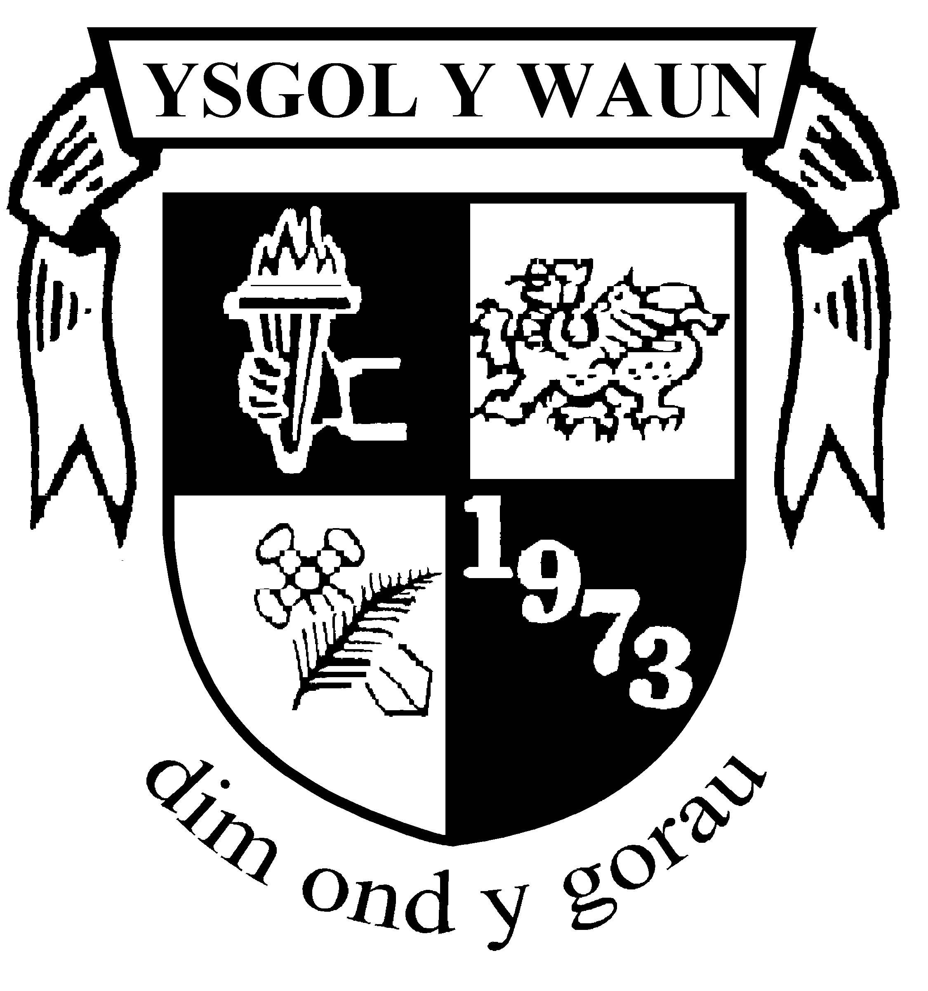

CCTV Policy

…..............................................
T Payne November 2021
Chair of Governing Body Date of Acceptance

Review Date November 2024

Introduction
This Policy is to regulate the management, operation and use of the closed circuit television (CCTV) system at Ysgol y Waun.
The system comprises a number of fixed cameras located around the outside of the building recording movement within the school grounds.
All cameras are monitored within the school. This Policy follows guidelines issued by the CCTV Commissioner and The Information Commissioner. The CCTV system is owned by the school.

Legal framework
This policy has due regard to legislation and statutory guidance, including, but not limited to the following:
• The Regulation of Investigatory Powers Act 2000
• The Protection of Freedoms Act 2012
• The General Data Protection Regulation (GDPR)
- The Data Protection Act 2018
• The Freedom of Information Act 2000
• The Freedom of Information and Data Protection (Appropriate Limit and Fees) Regulations 2004
• The School Standards and Framework Act 1998
• The Children Act 1989
• The Children Act 2004
• The Equality Act 2010

This policy has been created with regard to the following statutory and non-statutory guidance:
• Home Office (2013) ‘The Surveillance Camera Code of Practice’
• Information Commissioner’s Office (ICO) (2017) ‘Overview of the General Data Protection Regulation (GDPR)’
• ICO (2017) ‘Preparing for the General Data Protection Regulation (GDPR) 12 steps to take now’
• ICO (2017) ‘In the picture: A data protection code of practice for surveillance cameras and personal information’
This policy operates in conjunction with the following school policies:
Add in any policies that need to be cross referenced – eg Data Protection and photography in schools etc

Why does the school have CCTV?
To protect the school buildings and assets.
To improve personal safety and reduce the fear of crime.
To protect and maintain the well-being of people and their property who may be on the site.
To assist Staff in identifying and resolving incidents.
To assist the Police in a bid to deter and investigate crime and assist in identifying, and prosecuting offenders.

Policy Statement
Whilst operating CCTV we will comply with guidance and Codes of Practice issued by the Information Commissioner www.ico.org.uk and the Surveillance Camera Commissioner. We continue to be registered with the Information Commissioner under the terms of the General Date Protection Regulation and the Data Protection Act 2018 and will to the best of our ability comply with Data Protection, Privacy and Human Rights requirements. The school treats the system and all information, documents and recordings obtained and used as data in accordance with Legislation. Recordings will only be released to the media for use in the investigation of a specific crime following a specific request by the Police.

Lawful Basis for Processing
Cameras will be used to monitor activities within the school grounds to identify potential or actual criminal activity or behaviour which does not comply with school codes of conduct and for securing the safety and well-being of pupils’ staff and visitors. Static cameras will not be focused on private homes, gardens, vehicles or other areas of private property outside the perimeter of the school.
Processing is considered to form part of the Schools Public Task therefore the lawful basis of processing is considered under Article 6(1)(e,) of GDPR, which states that processing is necessary for the performance of a task carried out in the public interest or in the exercise of official authority vested in the controller.
Images of individuals captured by the system have a right to object and should follow the complaints procedure defined below.

CCTV coverage
Within the building there is no CCTV in place.
Warning signs are displayed appropriately, as required by the Code of Practice of the Surveillance & Information Commissioners.
The CCTV system will be operated 24 hours each day, every day of the year.

Protocols
The surveillance system will be registered with the ICO in line with data protection legislation.
The surveillance system is a closed digital system which does not record audio.
Warning signs have been placed throughout the premises where the surveillance system is active, as mandated by the ICO’s Code of Practice.
The surveillance system has been designed for maximum effectiveness and efficiency; however, the school cannot guarantee that every incident will be detected or covered and ‘blind spots’ may exist.
The surveillance system will not be trained on individuals
The surveillance system will not be trained on private vehicles or property outside the perimeter of the school.

Security
Access to the surveillance system, software and data will be strictly limited to authorised operators and is passcode protected.
The school’s authorised CCTV system operators are:
- Louise Ankers
- Andrea Taylor
- Linzi Jones
The main control facility is kept secure.
Surveillance and CCTV systems will not be intrusive.
Any cameras that present faults will be repaired immediately as to avoid any risk of a data breach.

Access
Under the GDPR, individuals have the right to obtain confirmation that their personal information is being processed.
All images belong to, and remain the property of, the school.
Individuals have the right to submit an SAR to gain access to their personal data in order to verify the lawfulness of the processing.
The school will verify the identity of the person making the request before any information is supplied.
A copy of the information will be supplied to the individual free of charge; however, the school may impose a ‘reasonable fee’ to comply with requests for further copies of the same information.
Where an SAR has been made electronically, the information will be provided in a commonly used electronic format.
Requests by persons outside the school for viewing or copying disks, or obtaining digital recordings, will be assessed by the Headteacher, who will consult the DPO, on a case-by-case basis with close regard to data protection and freedom of information legislation.
Where a request is manifestly unfounded, excessive or repetitive, a reasonable fee will be charged.
All fees will be based on the administrative cost of providing the information.
All requests will be responded to without delay and at the latest, within one month of receipt.
In the event of numerous or complex requests, the period of compliance will be extended by a further two months.
The individual will be informed of this extension, and will receive an explanation of why the extension is necessary, within one month of the receipt of the request.
Where a request is manifestly unfounded or excessive, the school holds the right to refuse to respond to the request.
The individual will be informed of this decision and the reasoning behind it, as well as their right to complain to the ICO and to a judicial remedy, within one month of the refusal.
In the event that a large quantity of information is being processed about an individual, the school will ask the individual to specify the information the request is in relation to.
It is important that access to, and disclosure of, the images recorded by surveillance and CCTV footage is restricted and carefully controlled, not only to ensure that the rights of individuals are preserved, but also to ensure that the chain of evidence remains intact, should the images be required for evidential purposes.
Releasing the recorded images to third parties will be permitted only in the following limited and prescribed circumstances, and to the extent required or permitted by law:
• The police – where the images recorded would assist in a specific criminal inquiry
• Prosecution agencies – such as the Crown Prosecution Service (CPS)
• Relevant legal representatives – such as lawyers and barristers
• Persons who have been recorded and whose images have been retained where disclosure is required by virtue of data protection legislation and the Freedom of Information Act 2000
Requests for access or disclosure will be recorded and the Headteacher will make the final decision as to whether recorded images may be released to persons other than the police.

How Long is data retained
Unless data is required for the above purposes by the school or investigatory bodies e.g. data will be kept for 28 days and then over-written. If required for investigatory purposes data will be destroyed as soon as it is no longer required.

Roles
Governing Body
The Governing Body is the Data Controller and owns the policy, fulfil a monitoring role, manage complaints and review the policy as appropriate. The Data Protection Officer Sarah Webb, will provide advice and assist in these functions.

Headteacher
Responsibility for overall operation of the System. The Headteacher has day to day responsibility and accountability for how the School uses CCTV systems, to approve access requests for to held data on CCTV. In their absence an appointed deputy may approve access.
Day-to-day management of the system and ensuring appropriate checks are carried out on a regular basis. Ensuring Data is disposed of appropriately

Data Protection Officer
To provide an independent overview of compliance issues. Provide advice and assistance when requested and advise and assist on complaints and the operation of the equipment. To monitor the Privacy Impact of the use of CCTV equipment.
Complaints
Any complaints about the school’s CCTV system should be addressed initially to the Headteacher. If the Headteacher is able to resolve the issue informally within 5 working days a report must be provided to The Governing Body.
If it is impossible for the Headteacher to resolve the issue informally the complaint will be passed to the Chair of Governors for consideration by the Governing Body and the Data Protection Officer.
Complaints may also be directed to the School’s Data Protection. Individuals also have the right to complain to the Information Commissioner’s Office www.ico.org.uk
Contacts
School Contact – Louise Ankers  Head teacher | Information Commissioner's Office  Wycliffe House  Water Lane  Wilmslow  Cheshire  SK9 5AF  www.ico.gov.uk
Ysgol y Waun Data Protection Officer – Sarah Webb  E2E Education  t: 07791 488938  e: sarah.webb@e2e-education.co.uk | Governing Body Contact – XXXX

The policy is dated from November 2021
The Policy and associated Privacy Impact Assessment will be reviewed in September 2021 or sooner if appropriate.
The policy and Privacy Impact will be reviewed by the DPO, The Headteacher and signed off by the Governing Body

